

GSMIXS
SMALL MIXER/UTILITY BAG
- High Tech Water Resistant Carbon Fiber Style Fabric
- High Density Foam body
- Plush fur lined interior and pockets for added cushioning and protection
- Heavy Duty, Grip-Dimple Bottom Lining
- Molded High Tech Lockable Rubber Zipper Pulls and Handles
- Removable, Adjustable Hefty-Grade Nylon Shoulder Strap w/ comfort Padded shoulder pad
- Industrial Grade Thick-Tooth Zippers
- Nylon, Velcro Gear Strap to hold equipment in place
- Quick Access, Oversized Utility/Headphone Storage Pocket with quick grab netting compartment to store small accessories
- Fits several PA, Recording, DJ Mixers, Guitar Pedals, Effects and other equipment ( see application notes for details)
- INTERNAL DIMENSIONS
- W 12-1/4 INCH X D 11-1/2 INCH X H 3-1/4 INCH
- W 311 MM X D 292 MM X H 82 MM

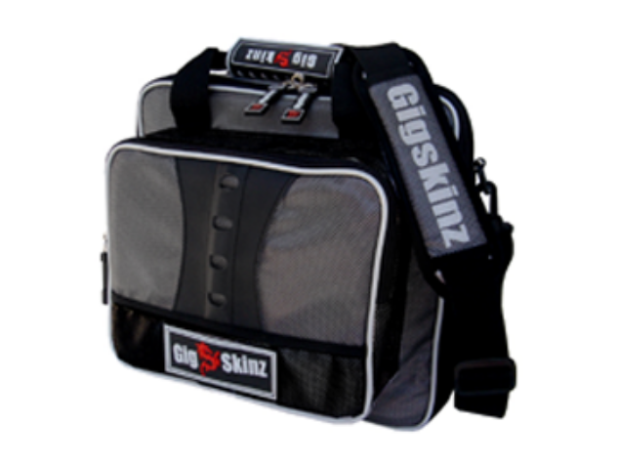

GSMIXM

MEDIUM MIXER/UTILITY BAG

GSMIXM
MEDIUM MIXER/UTILITY BAG
- High Tech Water Resistant Carbon Fiber Style Fabric
- High Density Foam body w/ structured Semi-Hard lining that maintains shape and protects gear from impact
- Plush fur lined interior and pockets for added cushioning and protection
- Heavy Duty, Grip-Dimple Bottom Lining
- Molded High Tech Lockable Rubber Zipper Pulls and Handles
- Removable, Adjustable Hefty-Grade Nylon Shoulder Strap w/ comfort Padded shoulder pad
- Industrial Grade Thick-Tooth Zippers
- Adjustable, Molded Velcro gear divider for Storage Flexibility
- Nylon, Velcro Gear Strap to hold equipment in place
- Quick Access, Oversized Utility/Headphone Storage Pocket with quick grab netting compartment to store small accessories
- Microphone Pocket with ID Storage
- Snap-on/Snap off Cell Phone Holder
- Fits several PA, Recording, DJ Mixers, Recording Studios, and other equipment
- ( see application notes for details)
- INTERNAL DIMENSIONS
- W 14-1/4 INCH X D 12-1/2 INCH X H 4-1/2 INCH
- W 362 MM X D 318 MM X H 120.65 MM

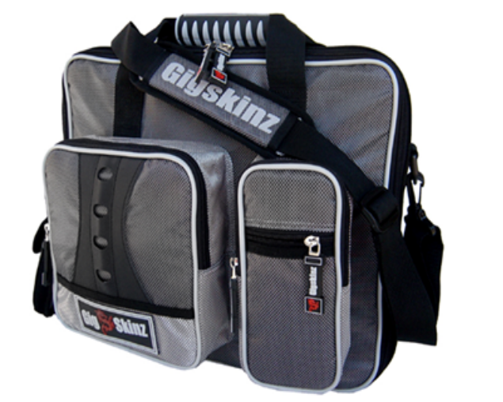

GSMIXL
LARGE MIXER/UTILITY BAG
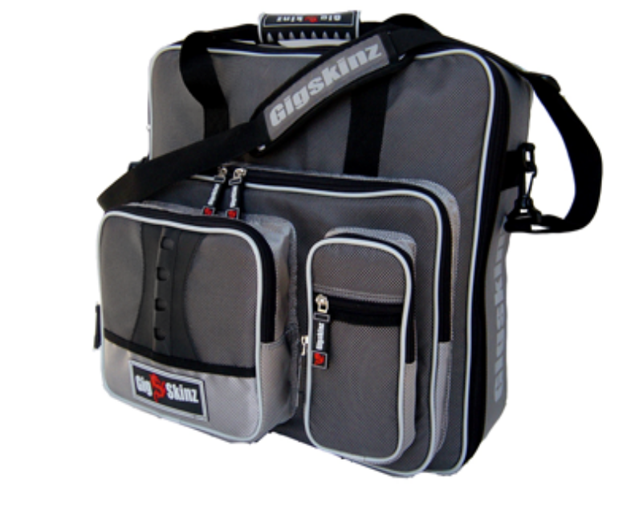
- High Tech Water Resistant Carbon Fiber Style Fabric
- High Density Foam body w/ structured Semi-Hard lining that maintains shape and protects gear from impact
- Plush fur lined interior and pockets for added cushioning and protection
- Heavy Duty, Grip-Dimple Bottom Lining
- Molded High Tech Lockable Rubber Zipper Pulls and Handles
- Removable, Adjustable Hefty-Grade Nylon Shoulder Strap w/ comfort Padded shoulder pad
- Industrial Grade Thick-Tooth Zippers
- Adjustable, Molded Velcro gear divider for Storage Flexibility
- Nylon, Velcro Gear Strap to hold equipment in place
- Quick Access, Oversized Utility/Headphone Storage Pocket with quick grab netting compartment to store small accessories
- Quick Access computer storage pocket - accommodates laptops up to 17”
- Microphone Pocket with ID Storage
- Snap-on/Snap off Cell Phone Holder
- Fits several PA, Recording, DJ Mixers, Recording Studios, Effects and other equipment ( see application notes for details)
- INTERNAL DIMENSIONS
- W 17-1/2 INCH X D 16-3/4 INCH X H 5-1/2 INCH
- W 444 MM X D 425 MM X H 140 MM

GSDJPAK
LP DJ BAG
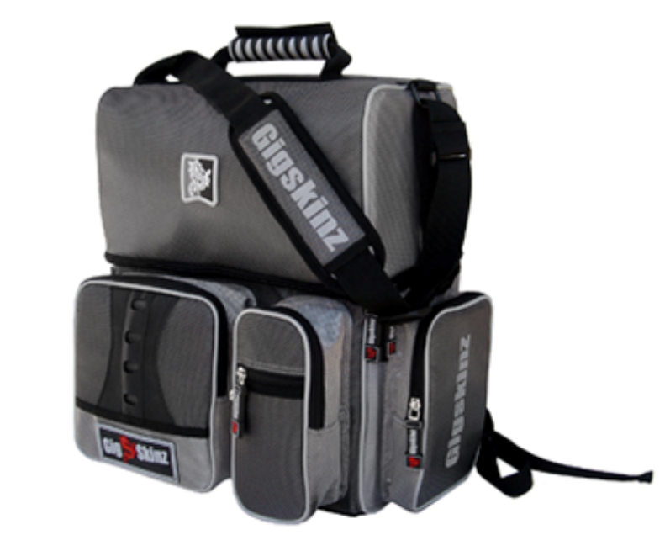
- High Tech Water Resistant Carbon Fiber Style Fabric
- High Density Foam body w/ structured Semi-Hard lining that maintains shape and protects gear from impact
- Plush fur lined interior and pockets for added cushioning and protection
- Heavy Duty, Grip-Dimple Bottom Lining
- Molded High Tech Lockable Rubber Zipper Pulls and Handles
- GIG-FLEX Carrying System - 3 carrying options
Removable, Adjustable Hefty-Grade Nylon
Shoulder Strap w/ comfort padded shoulder pad
Adjustable, comfort molded back-pack straps with Hide-away compartment
Molded High Tech Rubber Top Carrying Handle
- Industrial Grade Thick-Tooth Zippers
- Accommodates up to 50 LP’s
- Flip Back, Hidden, Quick Access Interior Storage Pocket in top for Gear and Accessories
- Quick Access, Oversized Utility/Headphone Storage Pocket with quick grab netting compartment to store small accessories
- Side Utility Pocket for Cables and Accessories
- Cartridge Pocket with ID Storage
- Snap-on/Snap off Cell Phone Holder
- INTERNAL DIMENSIONS
- W 13-1/4 INCH X D 7-1/4 INCH X H 17-3/4 INCH
- W 336 MM X D 184 MM X H 450 MM



