Road Ready Cases
12662 Corral Place, Santa Fe Springs, CA 90670
Ph: 562 906 6185 Fax: 562 906 6186
Email: usa@roadreadycases.com
www.roadreadycases.com

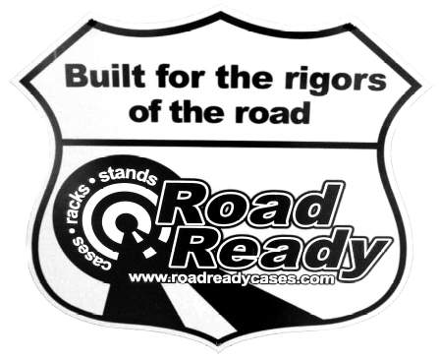WHAT SETS ROAD READY APART FROM THE
COMPETITION?

We do one thing and we do it well. We don’t waste time making cases that don’t last. We don’t make carpeted cases. We don’t make molded injection plastic cases. We don’t concentrate on stands, lighting or accessories. Why bother? We concentrate on one thing….. Building the baddest, toughest cases in the industry.
Our cases are built for the rigors of the road. Built to take a pounding day in and day out, and look good doing it. That’s our calling and we take it seriously. Hey, you invest a lot of money into your gear and you need the toughest protection around. Period. When you’re done playing around with the lightweights and get serious about protection,
bring in the BIG GUNS… Road Ready!

- Innovative Designs
Road Ready offers products and features not found in the products offered by the competition. Whether it’s the patented Climate Control case, Z-Lock Foam in our keyboard cases, or the Pick-&-Fit customizable foam in our utility cases; Road Ready cases contain innovative features that you can’t find anywhere else! We’ve even employed concept car designers from Porsche and Mercedes to design cases that will revolutionize the industry!

- Ultimate Quality
Why protect your equipment with anything less than the most rugged and durable case you can get?
Rugged Road Ready features:
-High Quality 3/8” laminated plywood
-Extruded aluminum trim with tongue and groove top-to-bottom fit
-Double anchor industrial rivets
-Heavy duty recessed handles and latches in all deluxe cases
-Corner joints secured with L-shaped corner flanges and six double anchor rivets
-Industrial grade stackable ball corners and removable rubber feet attached with threaded bolts and recessed T-nuts for extra secure connection

- Affordability
Road Ready cases are not only top quality, they’re also very affordable! Our quality to price ratio makes for an excellent return on your investment!

- Limited Lifetime Warranty
We believe in our products and stand behind them 100%. This is why we warranty our products to be free of manufacture defects for as long as you own your gear.

- One Stop Shop for Your Case Needs
Road Ready has it all… including: amp racks (regular and shock mount), effect racks, slant racks, Pro Mixer Cases, DJ coffins, turntable cases, DJ mixer cases, LP & CD cases, mic cases, PA mixer cases, keyboard cases, utility cases (for wireless mics, digital recording stations and many other applications), lighting cases, touring trunks and accessories: side wings, casters, battle bridges, and locks. Take advantage of the convenience and piece of mind found by fulfilling all your case needs with the quality products and excellent prices of Road Ready… your one stop shop for all your case needs!

