
GSK8
88 KEY KEYBOARD BAG -– FITS VARIOUS 88 KEY KEYBOARDS (SEE APPLICATION NOTES)
INTERNAL DIMENSIONS
W 53-1/2 INCH X D 11-1/2 INCH X H 5-1/2 INCH
W 1360 MM X D 292 MM X H 140 MM

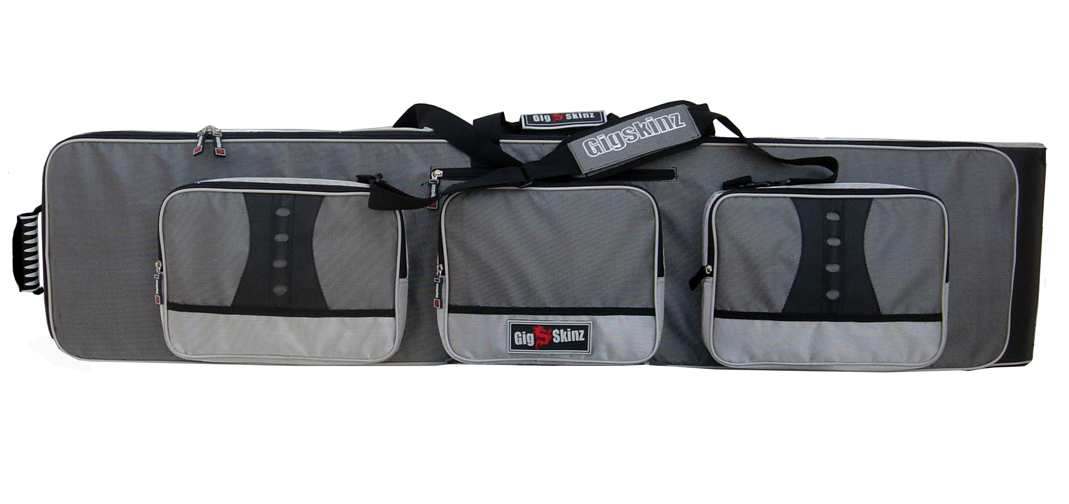
- High Tech Water Resistant Carbon Fiber Style Fabric
- High Density Foam Body w/ Hard Lining That Maintains Shape and Protects Gear From Impact
- Plush Fur Lined Interior and Pockets for Added Cushioning and Protection
- Heavy Duty, Grip-Dimple Bottom Lining & Feet
- Molded High Tech Lockable Rubber Zipper Pulls and Handles
- GIG-FLEX Keyboard Carrying System
Three Carrying Options;
-Hide-Away, Adjustable Hefty-Grade Nylon Shoulder
Straps w/ Comfort Padded Shoulder Pad
-Low Profile Blade Wheels and Molded Rubber Pull
Handle for Advanced Maneuverability
-Molded High Tech Rubber Top Carrying Handle
- Industrial Grade Thick-Tooth Zippers
- 5 Quick Access, Oversized Utility/Pockets for Cables,
Pedals, Documents and Accessories
- Hefty-Grade Extra Wide, Cushioned Gear Straps to Hold Keyboard in Place
- Two inch High Density Foam at the Bottom of Bag for Additional Keyboard Protection while using Wheels
- Snap-on/Snap Off Cell Phone Holder

