
GSK5
61 KEY KEYBOARD BAG - FITS VARIOUS 61 KEY KEYBOARDS (SEE APPLICATION NOTES)
INTERNAL DIMENSIONS
W 42 INCH X D 12-1/2 INCH X H 4-1/4 INCH
W 1066 MM X D 317 MM X H 108 MM

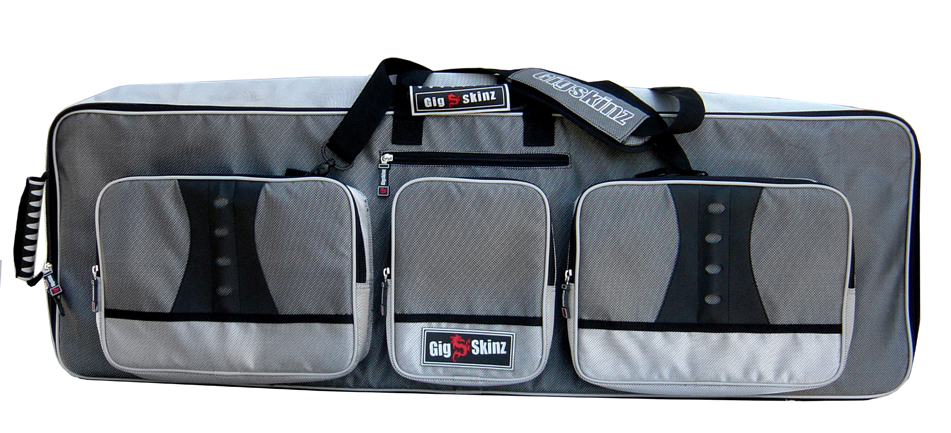

- High Tech Water Resistant Carbon Fiber Style Fabric
- High Density Foam Body w/ Hard Lining That Maintains Shape and Protects Gear From Impact
- Plush Fur Lined Interior and Pockets for Added Cushioning and Protection
- Heavy Duty, Grip-Dimple Bottom Lining
- Molded High Tech Lockable Rubber Zipper Pulls and Handles
- GIG-FLEX Keyboard Carrying System
Two Carrying Options;
-Hide-Away, Adjustable Hefty-Grade Nylon Shoulder
Straps w/ Comfort Padded Shoulder Pad
-Molded High Tech Rubber Top Carrying Handle
- Industrial Grade Thick-Tooth Zippers
- 5 Quick Access, Oversized Utility/Pockets for Cables,
Pedals, Documents and Accessories
- Hefty-Grade Extra Wide, Cushioned Gear Straps to Hold Keyboard in Place
- Snap-on/Snap Off Cell Phone Holder

