
GSBG
BASS GUITAR BAG - Fits most Bass Guitars

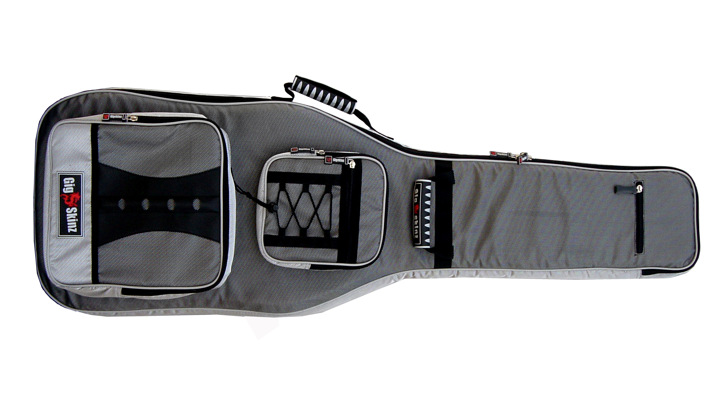

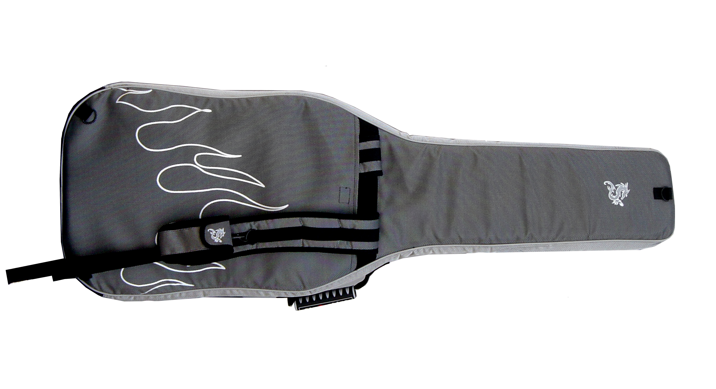

- High Tech Water Resistant Carbon Fiber Style Fabric
- High Density Foam Body that maintains Shape and protects Gear from Impact
- Plush Fur Lined Interior and Pockets for Added Cushioning and Protection
- Heavy Duty, Grip-Dimple Bottom Lining & Feet
- Molded High Tech Lockable Rubber Zipper Pulls and Handles
- GIG-FLEX Guitar Carrying System
Three Carrying Options;
-Adjustable, Comfort Molded Back-Pack Straps with
Hide-Away Compartment
-Two Molded High Tech Rubber Carrying Handles
- Industrial Grade Thick-Tooth Zippers
- Quick Access, Guitar Pedal / Accessories Storage Pocket
- Quick Access, Oversized Document / Accessories Storage Pocket
- Guitar Pick Storage Compartment
- Snap-on/Snap Off Cell Phone Holder
- Reflective Flames and Dragon Silk Screen on Back

