
Internal USE ONLY!

Waiver for Authorized Starin Dealers of Olevia-brand LCDs:

Section #4 of the Olevia Product Warranty states that the “Warranty does not cover “TV that has been used for commericial, non-household purposes.”

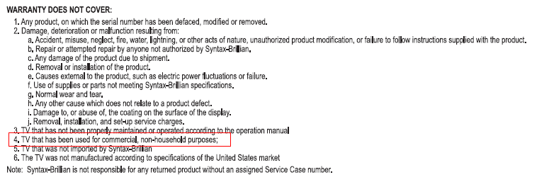

Syntax-Brillian Corporation hereby offers to Authorized Olevia-brand dealers of Starin Marketing a waiver of Clause #4 in the Product Warranty Program provided with each LCD. With the exception of Hotel applications, Syntax-Brillian will provide full warranty coverage for its LCD Products in commercial applications under the standard Warranty Program terms and conditions. Approval of Waiver #4 for Hotel applications must be approved on a case-by-case basis by Syntax-Brillian management.

Issued by:

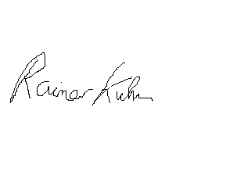

Rainer L. Kuhn
VP ProAV/Custom/OEM Sales & Product Marketing

October 31, 2006

