


PD9L Power Conditioner
Selling Points
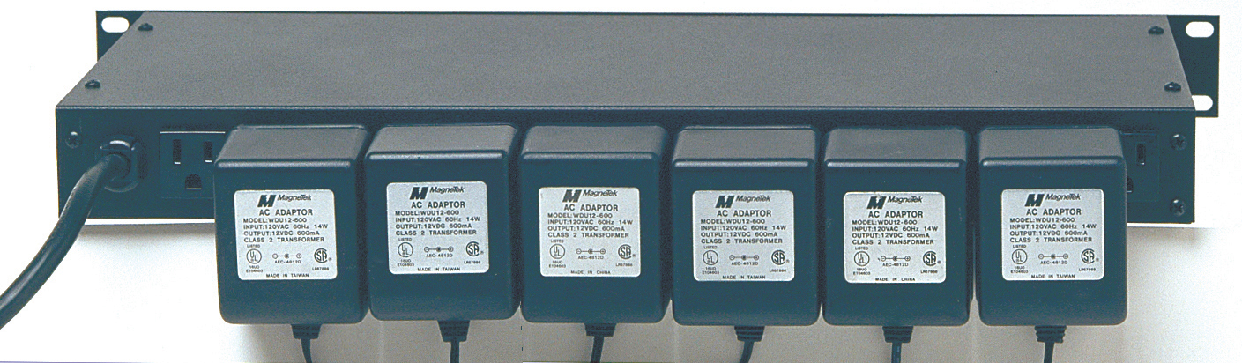
The ETA PD9L is now in Guitar Center stores; protect your gear with the best name in power distribution and protection!
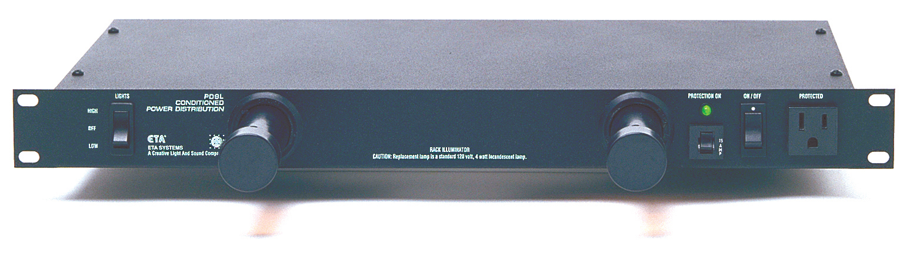

Feature | Benefit
SMART OUTLET DESIGN | CLEANED UP WORK AREA: Accommodates up to 6 “wall warts” on back with convenience outlet on front
COMPREHENSIVE POWER PROTECTION | FULL PROTECTION FOR YOUR GEAR: Voltage spike/surge protection on all 3 legs of incoming AC power.
CLEANS POWER | NO HUMS CLICKS OR BUZZES FROM YOUR ELECTRICITY: Radio Frequency noise filtration (and Electromagnetic) on all legs of incoming AC power ensures noiseless power
WATCHDOG™ PROTECTION | EASY “AT A GLANCE” ASSURANCE THAT PROTECTION IS ENGAGED WITH FRONT PANEL LIGHT
HIGH/LOW LIGHTS SWITCH | 2 POSITION LIGHT LEVEL SWITCH: Bright for set up & dim for performance. Superior to noise generating dimmers.
EASY BULB CHANGE | NO MAJOR SURGERY: Easy “In Rack” bulb replacement

Additional ETA Features:
- 15 Amp, 1800 Watts Capacity at 120V 50/60 Hz Single Phase
- Overload Protection
- 14-guage, 3-prong, 6 foot power cord
- Three Year Limited Warranty

ETA… The Benchmark By Which Professionals Compare.
For over 25 years ETA has developed, manufactured, and sold high amperage theatrical lighting systems from which have evolved an extensive line of rack mounted conditioned power distribution products designed to protect today’s sensitive electronic digital equipment.
ETA’s sophisticated electronic protection technology is the favorite of professionals who demand flawless operation of digital mixers, processors, amplifiers and PC’s – whether in the studio, in the boardroom, on tour, or guitar/processing rack.
- For more information, go to www.etasys.com
- To receive Power Facts via e-mail, send your e-mail request to eta@etasys.com

1532 Enterprise Pkwy ~ Twinsburg OH 44087~ USA ~ (800) 321-6699

