
Product Review – BenQ PE8700 Single-Chip 16:9 DLP Digital Projector – August, 2003

Introduction
The BenQ PE8700 is a video projector aimed directly at the Home Theater (HT) market. The 8700 is based on Texas Instruments' 16x9 (1280x720) HD2 or “Mustang” Digital Light Processing (DLP) or Digital Micro-mirror Device (DMD) that also uses Dark Metal technology for improved black levels and contrast ratios. I have seen almost the entire current crop of HD2 DLP-based projectors at various shows. However, this was my first chance to review one. I must say that the BenQ was an excellent place to start – they hit the target very well.
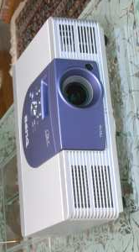
When it comes to features, perhaps the first thing that should be pointed out is that the BenQ 8700 has a short throw lens (i.e., short focal length, which means the picture size is larger at a given distance than with a long focal length lens), and is capable of producing a very big picture in a small room. (The other implications of this will be further discussed in the Installation and Room Placement section below).
The 8700 also has one other unusual feature, Picture In Picture (PIP) and and Picture On Picture (POP) that allows the user to show images from two different sources at once, either in PIP , small window in a large window, or in the side-by-side POP format. For instance, I found that I could display a small version of what my satellite receiver was seeing in the corner of my DVD movie playback. This might be used to show the program guide while you watch something else at the same time.
Although the 8700 is a high-end projector, it does not have several features that one might expect on full-featured HT projectors, e.g., power zoom, power focus, and lens shift. Although these power features are handy during setup, I would not let the lack of these features steer you away from the BenQ, as once set up, the image it produces is hard to fault. The 8700 is also one of the lowest cost HD2-based projectors you can find today.
The BenQ PE8700, like many of its HD2-based competitors, is specified to have a contrast ratio of 2000:1, and its brightness rating of 1000 ANSI lumens suggests that it might be somewhat brighter than many of its well regarded, and more expensive HD2-based competitors.
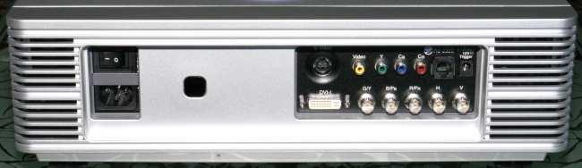
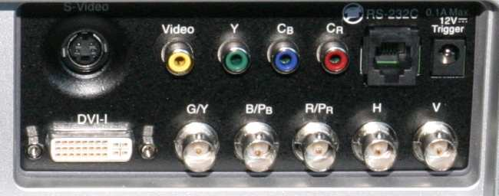
At this point, it is probably worth my admitting that I am getting the upgrade bug. I have been very happy with my Sony 11HT, but it is probably time to think about getting a new projector. I had hoped that the HD2-based BenQ would compare well with my 1364x748 pixel LCD-based reference projector in terms of resolution and sharpness, while at the same time having a smoother image without the annoying Screen Door Effect (SDE) typically associated with LCD-based projectors. Of course I also wanted the high contrast ratios and excellent black levels associated with DLP projectors, with hopefully enough brightness to make a truly engaging image. I want it all, and I’ll have to admit, in these respects, the BenQ met and exceeded my expectations!
Here is a link to a comparison of DLP vs. LCD.

Inputs and Connectivity
The BenQ PE8700 has a complete set of inputs on the back of the projector, as can be seen in the photo above. There are composite and S-Video jacks, RCA jacks for component inputs (interlaced only), and BNC jacks for either RGB or component inputs (interlaced and progressive input compatible).
There is also a DVI connector that supports inputs up to XGA (1024x768). BenQ's documentation does state that the DVI input is HDCP compliant (not tested). I was a bit disappointed when my attempts to use DVI in 1280x720 mode from my laptop led to a message that this format was not supported.
Controls
The lighted remote control has discrete controls for all inputs, aspect ratios, video memories, and menu controls. There are also controls for PIP and POP, and for screen up and down, assuming that you have a screen made by BenQ.
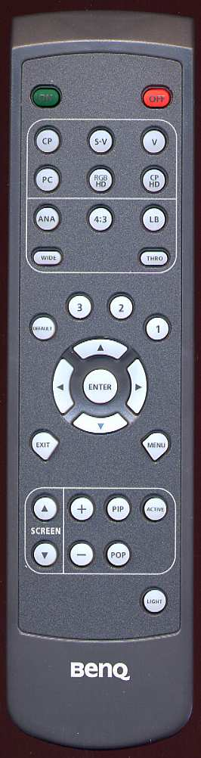
As is the custom, most of these buttons are also duplicated on the top of the projector, but you have to go through a menu in some cases.
I found the remote very easy to use, even in the dark, with logical placement of the various buttons.
Focus and zoom are adjustable via rotating rings accessible via a recess in the top of the projector.
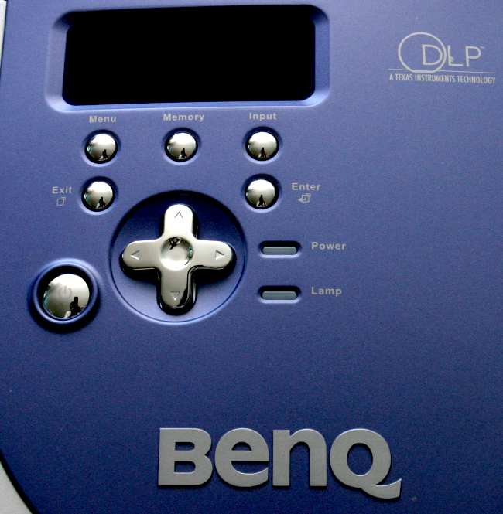
Menu System
The user menu system on the 8700 had a reasonable layout with most of the controls needed for tweaking located in the top “Picture” menu.
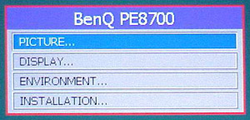
In the Picture menu, the user will find the typical Contrast and Brightness, Color, Tint, and Sharpness, along with a few other items, such as Color Temp, Filter, and Red, Green, Blue, and Yellow(!) levels. As you will see in the Measurements and Viewing sections, some of these controls had unexpected, but useful functionalities.
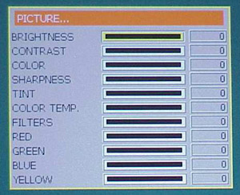
The Display menu on the 8700 allows entry of Source and Display formats, as well as Loading and Saving settings in the three user video memories.
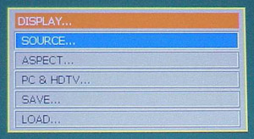
The Installation menu handles the typical chores of front/rear and ceiling/floor installations. This menu also allows the user to display a useful focusing pattern, although I thought it reverted to the normal display a bit too quickly for my focusing habits.
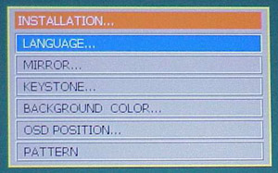
The Environment menu shows the lamp usage in hours and minutes(!) and also allows the user to reload the Default values for the current input source. While I never used this function, it certainly could come in handy if tweaking goes astray.
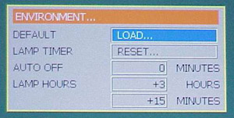
Installation and Placement in the Room
As mentioned in the Introduction, the BenQ PE8700 has a short throw lens, i.e., the distance from the screen to the projector needs to be between 1.36 to 1.66 times the screen width. This is just what is needed to replace most CRT projectors as they tend to have similar throw ratios. This throw ratio will likely mean that the 8700 will need to be placed in the room in front of, or roughly at the same distance as the seating area.
With a short throw lens, you will also need to be careful in the selection of a projection screen. Screens with significant gain should probably not be used with the 8700 in order to avoid hot-spotting. If you need to use a screen with significant gain, make sure that the projector is at the far end of it throw ratio. Fortunately, as you will see in the Measurements and Viewing section, the BenQ is more than capable of making a bright punchy image with a unity gain screen (a gain of 1), such as the one I own.
The lack of the lens shift feature means that you will need to carefully place the 8700 vertically to avoid the use of digital keystone correction. It is worthy of note that the proper vertical position is slightly below (table mount) or slightly above (ceiling mount) the bottom or top or the screen. The vertical offset in my setup was about 3 inches. This is certainly not a problem, and in most cases is likely an advantage, e.g. if I were to permanently mount the BenQ, the offset would put the projector a bit closer to the ceiling. Just keep this need for a vertical offset in mind in your installation planning, as well as the fact that the lens is also a bit left of center.
When I powered up the 8700 I was immediately impressed how quiet it was. The specification for noise level is < 30 dB. When it comes to Spousal Acceptance Factor (SAF), one of the things my wife often mentions about the various projectors we have had the privilege of testing is, “Why does it have to be so noisy”? I agree, a low noise level is very important in the HT environment, and I have yet to experience a projector that is as quiet as my ceiling-mounted 11HT. The 8700 starts up very very quiet, but after it warms up a bit, the fan speed increases and then typically cycles between two speeds every 15 to 30 seconds or so. With the projector mounted on a table in the middle of our seating area this was noticeable and a bit distracting in quiet scenes. It should also be noted that the fan noise and air flow comes from the front and back of the projector, not the sides.
BenQ claims that their 6 segment, 5x speed color wheel has a proprietary anti-vibration design. What I can say is that all of the noise from the 8700 sounded like moving air – white noise – with none of the usual color wheel “whine” that I have heard with other 1-chip DLP projectors. I strongly suspect that if the 8700 were ceiling mounted in the same position as my 11HT (a very tempting possibility!), and therefore further away, that the noise level would not be an issue.
Measurements and Viewing
I’ll have to admit that when I first started testing the 8700, I was a little frustrating. When I get a new projector to review, I set it up on the coffee table, connect the component DVD inputs, put on Avia for initial brightness and contrast adjustments, and get an initial impression of the projector. The problem was, that there was no image coming from the BenQ, only a faint 4x3 rectangle in the middle of my 16x9 screen, and an occasional flicker of a double-picture. It seemed as if the 8700 would not sync with my DVD player! It took me a little longer than it should have to figure out that the problem was that the RCA component inputs on the 8700 only support interlaced inputs, and my Denon 1600 DVD player was set up for a progressive output. Switching the DVD player to an interlaced output solved the problem, and I then had a 16x9 image that more than filled my screen.
I bought some RCA to BNC connectors at Radio Shack (Cat # 274-254) so that I could use the BNC jacks on the BenQ with a progressive input from the DVD player, as well as use my DISH 6000 HDTV receiver. I then proceeded to go through the normal setup of the user controls using the usual Avia test images.
User Level Adjustments
The Black Bars test on Avia is very good image for setting the brightness, as it presents two almost black moving bars that are just above or lighter than black. At the proper brightness setting, you should just be able to see the darker of these moving bars, and easily see the lighter one, thus assuring that shadow details are properly distinguished from black. However, using the progressive component input with the 8700 I was unable to see the darkest moving bar at any Brightness setting.
I experienced a similar problem with the almost-white moving bars on the Needle Pulse test image. In this case, I could not see either one of the almost-white bars at any Contrast setting, even when I lowered Contrast to the point where the overall light output of the projector was noticeably reduced. This was most disconcerting, as it suggested that both shadow detail and highlight details are crushed using a progressive DVD input.
My attempts to adjust Sharpness led to similar confusion – the Sharpness control seemed to have minimal effect when looking at the Sharpness test image. So, I set it at –5, on general principles, and scratched my head. As Perot might say, I was beginning to think that my “little gray cells” were starting to fail me.
I switched to an interlaced input and now all the tests and adjustments worked just as they should, with either the RCA or BNC jacks. Both almost-black bars appeared and disappeared properly with adjustment of the Brightness control, and both almost-white bars were visible and acted appropriately with adjustment on the Contrast control. I quickly determined that the proper Brightness setting was 32 and the proper Contrast setting was 18. The Sharpness control also behaved properly, although I did not check that at this time. I’ll discuss the Sharpness and Filter setting in more detail in the viewing section.
Using the usual test image on Avia, I set the Color control at 36 and Tint at 17.
I checked the response of the Color Temp and the Red, Green, and Blue controls. In the manual the Color Temp control is described as follows:
0 : The default color temperature of the lamp.
1 : Low color temperature (6500°K). Makes white appear reddish.
2 : Middle color temperature (7500°K). Maintains normal colorings for white.
3 : High color temperature (9300°K). Makes white bluish.
A Color Temp Setting of 0 gave a very bright yellowish looking white, but the other settings looked about as described. (More about this in the measurements section.)
My next surprise was that the user RGB controls had absolutely no effect on the color balance of white or any level of gray, and therefore no effect on grayscale tracking! What these control did, however, was effectively to control the saturation of the respective colors in the color decoder. So when looking at the Color Decoder test on Avia, one could use these controls to set the saturation level of each color – very handy. This is a control that I wish more projectors made available in the user menu, as it allows one to correct for “red push”. I was able to dial in all three colors to the correct level; I boosted green by 2 to 19, lowered red by 1 to 16, and left blue at the default value of 17.
Video Memories
The 8700 has three user video memories as well as a system that automatically stores all user menu settings separately for each input. It also automatically selects the appropriate set of stored values with each change of source. The automatic system is all that I find I need for daily usage, but the user memories can be handy at other times.
Measurements
When I evaluate a projector, I not only look at images, I measure the color balance of the projector at various light intensity levels and determine the quality of what is called ‘grayscale tracking’. The idea is that black, white, and all shades of gray, should have the correct ratio of the three primary colors used in video projection Red, Green and Blue. You can read more about the testing method in my past projector reviews on Secrets, or at http://www.smartavtweaks.com
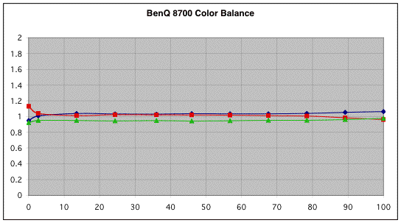
The Color Balance data from the 8700 with the Color Temp control set to 2 is shown above. Obviously, the measured color balance of the 8700 is very flat as a function of IRE level, and the Correlated Color Temperature (CCT) at this setting was close to 6800K. Similar data were obtained with a Color Temp setting of 1, but in that case the CCT was closer to 6100K and the image did appear a bit red. Since I was unable to affect grayscale tracking with the user controls, and since, frankly, the image looked great as it was, I left the Color Temp control at 2 moved on to viewing. No advanced tweaking was really necessary with the BenQ 8700!
Oh, perhaps I should mention that, as calibrated, the IRE 100/IRE 0 contrast ratio was 1795:1 and the IRE 100 window produced an image that measured 19 ftL at my 102” diagonal unity gain (gain=1) DaMatte screen. This corresponds to 597 Lumens light output from the projector. Needless to say, both numbers represent excellent performance. (I have no doubt that with the Color Temp set to 0, the much brighter image would have allowed the BenQ to exceed both its contrast ratio and Lumens specifications. However, the color balance would be off in this case.)
Gamma Tracking
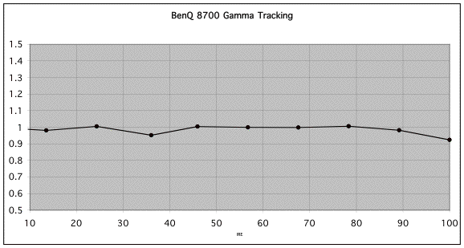
The other thing we can measure is gamma tracking, or how the light output of the projector responds to the input signal. If the projector's gamma tracking is off, then details in the image will either be lost or the image may look flat and have little contrast. The Gamma Tracking graph shows the combined light intensity at the various IRE levels relative to a theoretical level. If the projector is accurately producing the intended light intensity level as a function of input or IRE level, all values should be close to 1 in the gamma tracking graph.
In the Gamma Tracking graph above we can see that the 8700 has very accurate gamma tracking that is well described, with an overall gamma of 2.51 – the ideal gamma for a video display!
You may notice that the data points for the graphs shown above don't line up with the 10, 20, 30, etc. IRE levels specified on the X axis. This is because the IRE levels on the Avia disc are not exactly at 10, 20, 30, etc. We use the actual IRE numbers, i.e., IRE 10 on Avia is actually IRE 2.7, IRE 20 on Avia is actually 13.5, etc.
Scaler and Deinterlacer – The Video Essentials Montage
Since for the reasons stated above, I used an interlaced DVD input with the 8700, its deinterlacer performance became of critical importance. I checked the performance of the deinterlacer using the montage on the Video Essentials (VE) disc with the interlaced component output from my Denon 1600 DVD player. The pan back from the building was fine, the leaves showed a bit of twitter, and the waving US flag was better than I typically see with the deinterlacer built into most projectors. I really did not see jaggies (jagged diagonal lines) in the flag, but it was not have quite as smooth as I typically see with the progressive output of my DVD player. All in all, I decided that the built-in deinterlacer was up to the job and used the interlaced DVD mode for all critical viewing.
Viewing and Comments
Once I had worked out some of the 8700's, err . . . um . . . idiosyncrasies, the image was truly sensational. Let’s examine why. With a white level on my screen of at 19 ftL, the 8700 is nearly twice as bright as my reference projector (Cinema black and CC 40R filter in place), as well as most of its direct competitors. A 19ftL image is a bright involving image just above the light levels typically found in commercial theaters. I find 16 to 20 ftL to be just about right for viewing in a darkened room.
I remember well an occasion where my wife and I watched "Lord of the Rings" on another HD2-based DLP projector with an 1800:1 contrast ratio, but with a considerably lower light output level than the BenQ. I was impressed with the black levels, but my wife said that she thought the picture looked too dark. With the 8700, the picture never had a dark or dim feeling unless, of course you were in the mines of Moria, and then it looked really dark, as it should!
I think that it is partly a matter of balance and partly a matter of what you are used to viewing. With a sound system, if you have extended highs and extended lows, it sounds balanced. If you have extended lows, but the highs are muted, the system will likely sound heavy. Perhaps having both the whites brighter and the blacks blacker than our reference projector made the image seem well balanced. With a gamma of 2.5 the image had punch and did not look at all soft in comparison with my reference projector (which also has a gamma of 2.5).
Thus, with the 8700, the combination of brightness contrast ratio and the ideal gamma of 2.5 meant that the luminous part of the image signal was handled about as well as can be handled today. Well done, BenQ.
Another part of the image quality obviously involves color and color saturation. Getting rich well-saturated colors is often a problem for single-chip DLP projectors relative to their LCD-based counterparts. While the DMD chip itself is very efficient in the use of light, in single-chip DLP designs, color is achieved by alternately passing light through RBG filters in the color wheel, and the designer may need to compromise color saturation in order to improve overall brightness, and, of course, the all important Lumens rating. The more saturated the Red, Green and Blue filters, the better the color saturation in the image, but at the cost of light output. If, on the other hand, the filters were a bit on the “light” side, e.g., a light green filter instead of a forest green filter, then you get more light output, but a less saturated green color.
When I first fired up the 8700 my distinct impression was the BenQ had probably used a fairly light green filter in their color wheel. Reds were great, blues, OK, but greens were definitely on the “light” green side. The greens in the VE montage and the “green” color field on Avia looked a bit insipid. Fortunately adjusting the RGB user controls to increase the green saturation helped quite a bit. Once adjusted, I was never really bothered again by poor color saturation in normal viewing. The greens were not as saturated as with my reference projector, but to be fair this is a common issue with single chip DLP projectors, not just the BenQ. Color saturation actually looked very good at the lower IRE levels where the high contrast ratio keeps colors from looking washed out.
Sharpness is the next issue that needs to be discussed. With all but perhaps one exception, if I asked my wife what she thought of the image of the projectors I have reviewed, inevitably the response also included, “It’s not as sharp as our projector; I don’t like it as well.” Frankly, it’s hard to beat the sharpness of the Sony 11HT with its 1364x768 resolution and its excellent (and large) lens.
I was therefore anxious to see how she would feel about the sharpness of the HD2-based 8700. Although its pixel resolution of 1280x720 is slightly less than our reference projector, the lack of SDE, or pixel grid, in the image should, perhaps, make up for some loss in resolution. This is especially so with DVD where the projectors have far more resolution than the source.
On the first evening, we were watching "Lord of the Rings" – it’s sort of a rite of passage for any new projector – and I was surprised that it was me saying, “Wait a minute, this projector is not nearly as sharp as ours”. She certainly agreed. No question about it. We were watching the first scenic views one gets of Lothlorien, with its waterfalls and intricate architecture. In the next few scenes, it was clear, something was wrong with the sharpness of the image.
The following day, I decided it was time to explore the Sharpness control again. Perhaps lowering it to –5 was not such a good idea after all. I found that there were two parameters that I had to get right to get good sharpness without obvious artifacts. The first was the Filter setting. For video, Filter settings of 0 to 3 are available, with the higher settings supposedly giving better detail. By looking at the Sharpness test on Avia, it was clear that Filter settings of 2 and 3 gave noticeable ringing, or white edges on either side of black lines. It was also clear that a Sharpness setting of less than 0 softened the image. I ended up using +3 for subsequent viewing. I also checked these settings on the Lothlorien scenes and was much happier with the result. This projector was pretty sharp after all. Details do matter.
Dithering? Rainbows? Neither was a issue for me with this projector, although it seems I am less sensitive to Rainbows than some. Dithering has bothered me with some DLP-based projectors, but I’ll have to say that there was not one scene where I saw any evidence of dithering from my normal viewing position. Sure, if you hit pause on the remote and walk up to the screen, you can see dancing pixel intensities in dark areas of the screen, but from my normal viewing position, dithering artifacts were not an issue for me.
So how about HDTV? When I first hooked up my DISH 6000 to the BNC-based component inputs, I was impressed with the overall image quality. There were however, a few more motion artifacts than I was used to seeing in various scenes with vertical pans. It occurred to me that the 1080i output setting that I prefer for my 11HT was not optimal for a 1280x720 projector. Switching the DISH 6000 to 720p solved this problem and now vertical pans were smooth and without obvious artifacts. HDTV was really sharp on the 8700.
One evening, "Men In Black II" was on in HDTV. It was an excellent movie to show off the great black levels and high contrast ratio of the 8700. "Dead Like Me" on ShowTime HD also looked great, as did the various travel-logs or historical docu-dramas that we watched on the Discovery HD channel.
On our last evening with the projector, we put on Disc 2 of the extended version of "Lord of the Rings, Fellowship of the Rings". This time I was very impressed. The image was smooth and it was sharp. Several of the scenic views of the rocks and mountains took on a 3-Dimensional quality that I had never seen before with this or any other DVD. The low SDE really seemed to help make the image not only smoother, but more realistic as well.
At this point, I was getting hooked on this projector pretty quickly. It was a good thing I only had the 8700 for a week, because another few days and I might not have been able to let it go. I expectantly asked my wife what she thought of The BenQ projector, and she said, “It looks very good”. Now that is what I call a breakthrough!
I haven’t decided on an upgrade for my trusty Sony 11HT, but I am definitely thinking about it. The 11HT usually looks pretty good when I see it again after spending significant time watching another projector, but I’m afraid not this time. The SDE was pretty obvious when I hooked the 11HT up again. Discovery HD was on, and this time it was my projector that didn’t look so sharp. Hmm. There is no doubt that the BenQ is currently on my upgrade short-list, with its excellent all around performance. It also passes some of my more practical tests such as mounting on the ceiling in the same place as my current projector, and working well with my current matte white screen. It is also a very nice looking unit. I do plan to check out quite a few other projectors in the next few months. We’ll see what happens.
Conclusions
If you read this far, you must know that I really like the BenQ PE8700. It produces an excellent image with an an ideal gamma of 2.5, an honest 1800:1 contrast ratio, and a very bright 19 ftL image on my 102” diagonal matte white screen. The colors, especially green, are a bit “light” in color, but overall the image quality is excellent. Some of the inputs are not quite as versatile as you would expect, so check out the details in this review before you buy. You should also make sure that the short throw ratio of the 8700’s lens will work with your planned installation. If you do decide on the BenQ PE8700, chances are you will really like the bright sharp punchy image it produces. My wife and I certainly did.

- Steve Smallcombe -

Specifications:
● R1280x720 TI HD2 (“Mustang”) DLP Chip
● 2000:1 Contrast Ratio
● 1000 ANSI Lumens
● 6 segment, 5x speed color wheel with a
proprietary anti-vibration design
● Sealed Optical Path
● 1:1.2 Zoom Lens, 1.36- 1.66 x Screen
Width
● 10-bit Proprietary Gamma Correction
● 3:2 Pulldown Detection
● Adjustable Video Filters
● PIP and POP
● Supports Composite, S-Video,
Component, DTV Y/PB/PR, DTV RGB and
DVI-I
● Digital Keystone Correction ± 15°
● 200 Watt Lamp – 2000 Hours life
● RS-232 Control Port, 12V trigger
● Noise Level < 30 dB
● Size: 17.75” x 4.72” x 11.1”
● Weight:17 Pounds
● MSRP: $5999 USA

BenQ
www.benq.com

Copyright © 2003 Secrets of Home Theater and High Fidelity
http://www.hometheaterhifi.com

